Email Etiquette for Corporate Professionals

Demonstration Storyboard by Elizabeth Ilawan

Screen 1
Audio Narration | Visuals
Welcome to Email Etiquette for Corporate Professionals.  Proper email etiquette is important for fostering healthy communication with colleagues and clients, but there are no hard-fast rules regarding what is and is not acceptable in email correspondence. In this module, we will explore some of the most common best practices for email messages so that you can communicate with confidence.  Select the “Begin Module” button to continue. | Welcome  On-screen Text: EMAIL ETIQUETTTE For Corporate Professionals In this brief eLearning module, we will explore various tips for email correspondences that ensure professional and cordial communication. <<Begin Module>> 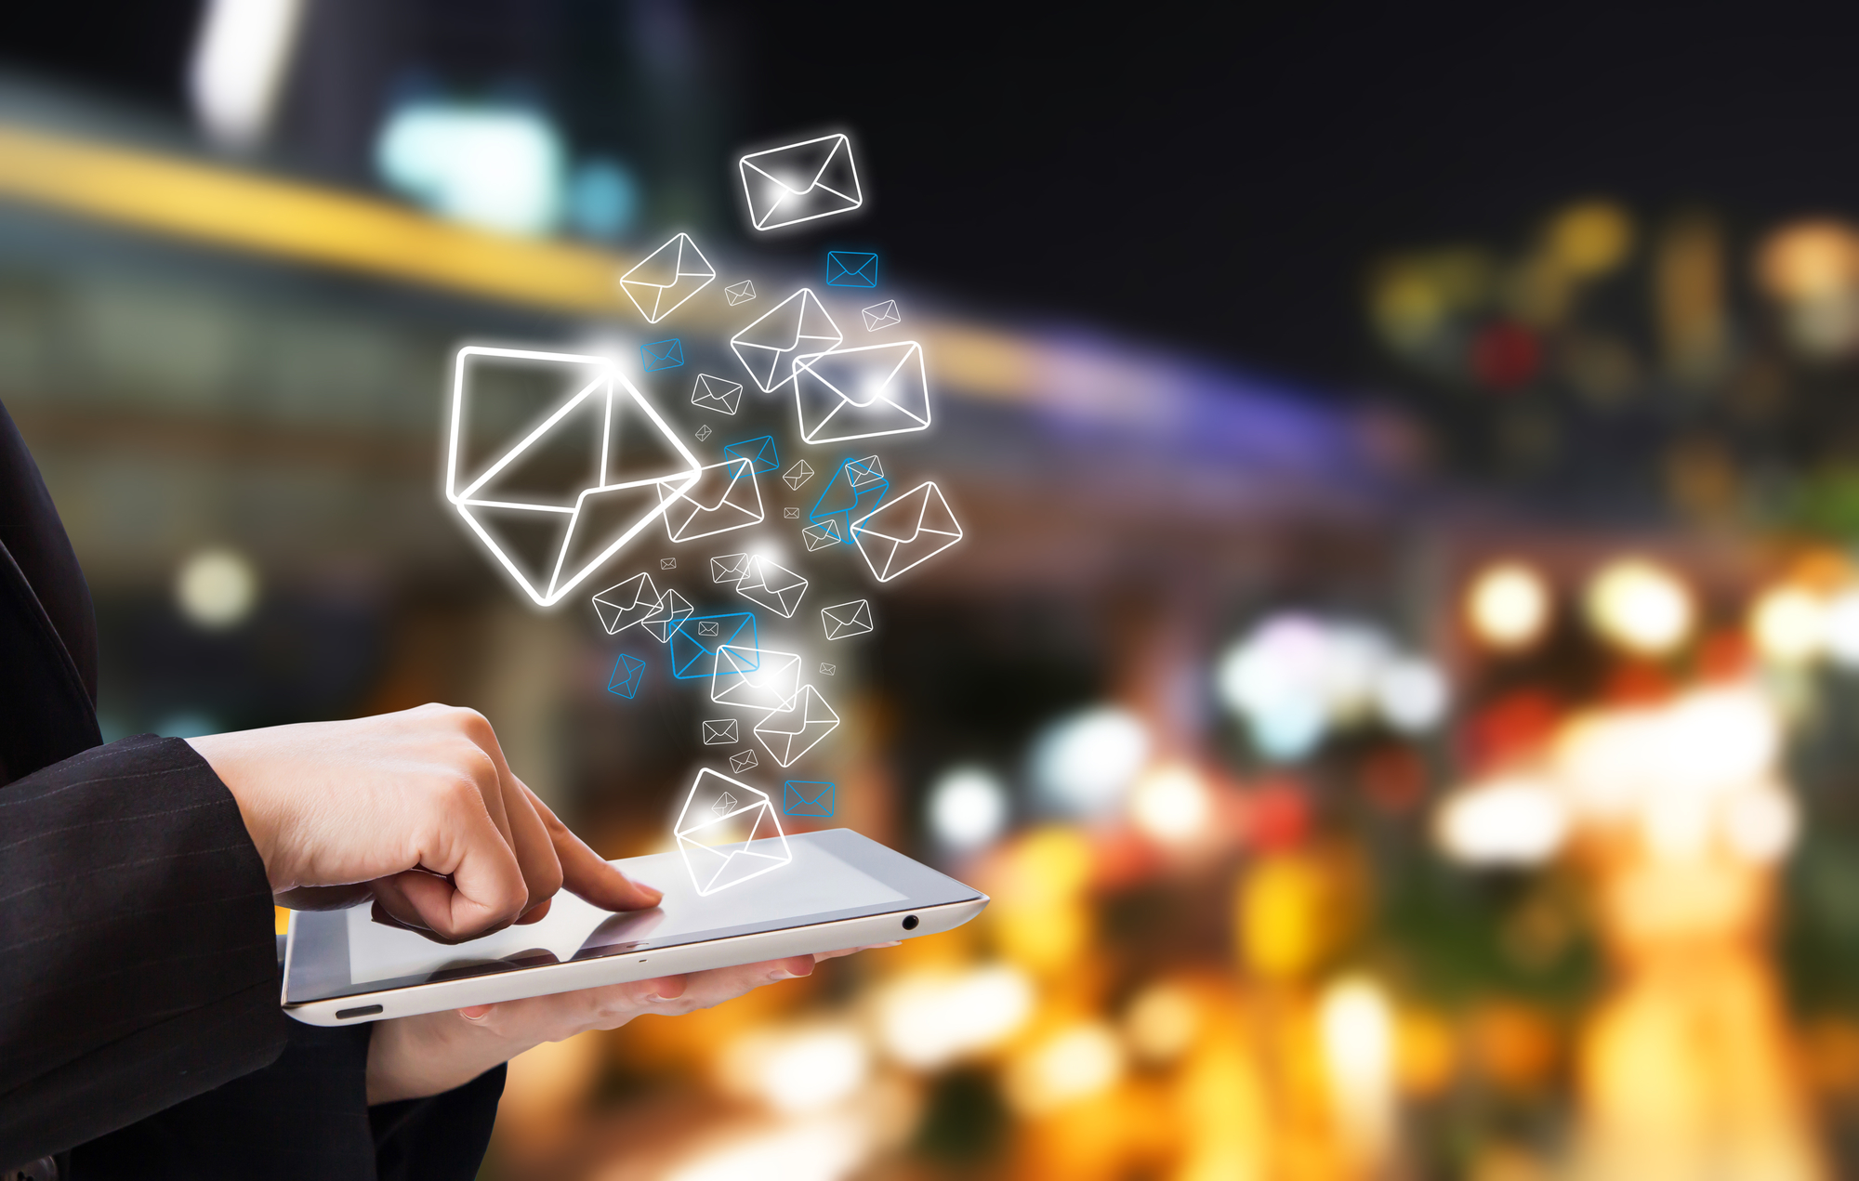  Use split-screen layout
Instructions for Interactivity
- Play narration on screen open.
- Image on right fades in as slide loads.
- On-screen text fades in by paragraph.
- Begin Module button appears after narration cue.

Screen 2
Audio Narration | Visuals
In this module, you will:  - Determine what is proper etiquette for email communication  - Decipher which email elements are necessary for proper email etiquette  - Discern an appropriate email from that of an inappropriate one  Select the “next” button on the player to continue. | Module Objectives  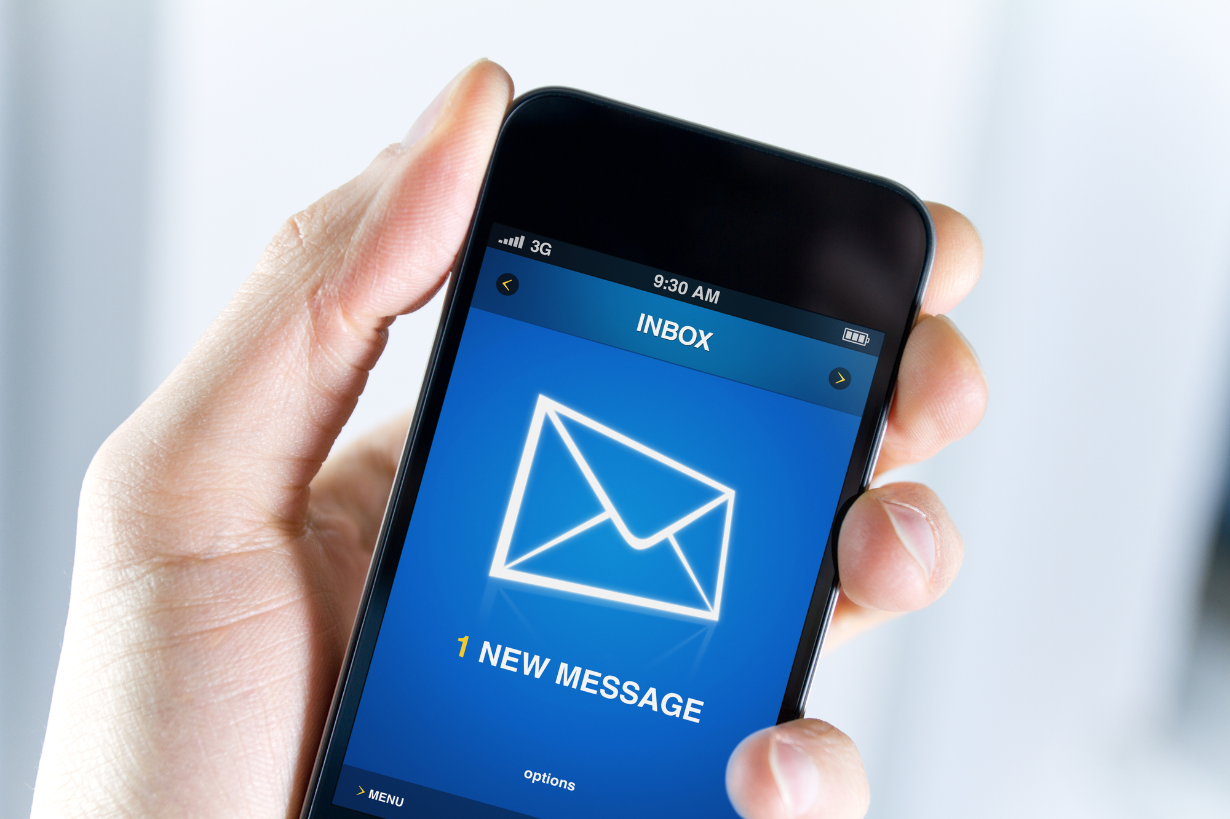 On-screen Text: MODULE OBJECTIVES In this module, you will: - Recognize what is proper etiquette for email communication - Recall which email elements are necessary for proper email etiquette - Distinguish an appropriate email from that of an inappropriate one  Use split-screen layout
Instructions for Interactivity
- Play narration on screen open.
- Image on left fades in as slide loads.
- Slide title flies in from right-hand side.
- On-screen bulleted text fades in by paragraph synced with audio narration.
- User selects “next” button on player to advance slide.

Screen 3
Audio Narration | Visuals
The rules of email etiquette are not stead-fast, but can however determine what’s appropriate and what’s not when communicating to a client, business associate, colleague, or supervisor. These best practices can also help foster open communication and avoid mistakes. Let’s ensure that you have a good understanding of email etiquette.  Select the “next” button on the player to continue. | Importance of Email Etiquette    On-screen text:  The rules of email etiquette are not stead-fast but can however determine what’s appropriate and what’s not when communicating to a client, business associate, colleague, or supervisor. These best practices can also help foster open communication and avoid mistakes. Let’s ensure that you have a good understanding of email etiquette.
Instructions for Interactivity
- Play narration on screen open.
- Image on top fades in as slide loads.
- On-screen text fades in all at once on screen open.
- User selects “next” button on player to advance slide.

Screen 4
Audio Narration | Visuals
The following section of this module will highlight difference email scenarios you might encounter at work. For each scenario, you will be asked to reflect on each message and determine if there are any errors or issues regarding proper email etiquette. Don’t worry if you don’t know the proper etiquette for a particular scenario, just try to do your best. Keep in mind that these scenarios are meant to teach you about appropriate email etiquette in a way that gets you involved as a learner. | Email Scenarios   On-screen Text: EMAIL SCENARIOS The following section of this module will highlight difference email scenarios you might encounter at work. You will be asked to reflect on each scenario and determine if there are any errors or issues regarding proper email etiquette. <<View Scenario>>  Use split-screen layout
Instructions for Interactivity
- Play narration on screen open.
- Image on left fades in as slide loads.
- On-screen text fades in all at once.
- View Scenario button appears after 7 seconds.

Screen 5
Audio Narration | Visuals
Kim is composing an email to her coworker regarding a report they submitted on January 16th. Do you see any errors or anything inappropriate? Take a moment to read through it and then select the “review” button to determine if this email conforms to proper email etiquette.  Review (layer)  Select select each marker to learn more regarding the issue with this email. | Email Scenario 1  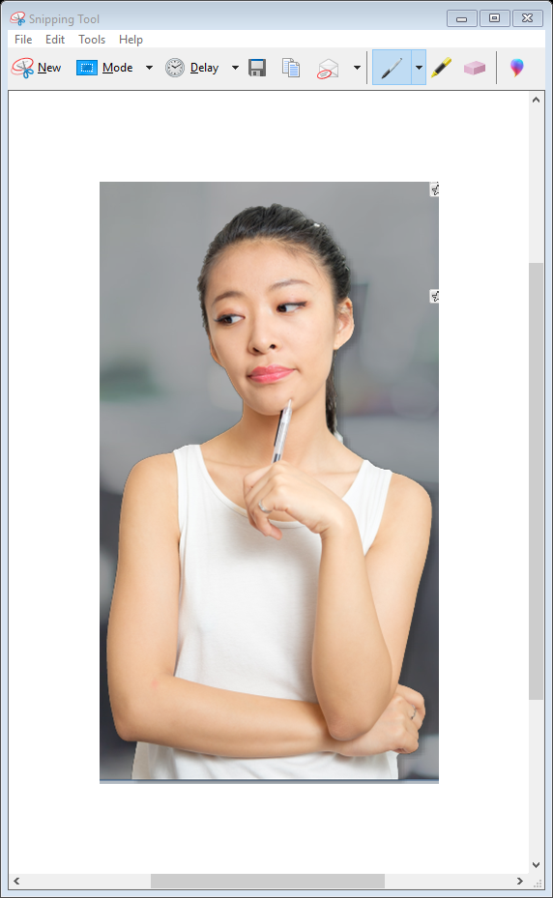 Scenario Text: Kim is composing an email to her coworker regarding a report they submitted on January 16th. Do you see any errors or anything inappropriate? Sample Email Text: Hiya! Hey Jeff Appreciate the help on that report we did last week. I’m having trouble finding it in my email. Can you send it to me? Thanks, Kim <<Review button>>
Instructions for Interactivity
- Play narration on screen open.
- Character on left flies in from bottom as slide loads.
- On-screen scenario text fades in all at once.
- Sample Email Text flies in from right.
- View Scenario button appears after 6 seconds
- When user selects Review button overlay appears with screen-shot of email and marker buttons near subject email line and salutation.
- Selecting Subject Line marker triggers overlay with the following text:
  - SUBJECT LINES: This subject line is not descriptive enough for this email. Ideally, it should inform the recipient about why Kim is emailing them. A Better Subject Line: “Report Submitted January 16, 2019” This is a clear and concise way of stating exactly what the email is about.
- Selecting the Salutation marker triggers overlay with the following text:
  - SALUTATIONS: The first line of an email is where you address the recipient by name. This email lacks punctuation. For formal email, use a colon. “Dear Mr. Carlton:” For informal email, use a comma.“Dear Jenny,”
- Continue button appears on screen open.
- When user selects continue button, interactive advances to next slide.

Screen 6
Audio Narration | Visuals
Andre is responding to an email from his supervisor regarding a shipment inquiry. Do you see any errors or anything inappropriate? Take a moment to read through it and then select the “review” button to determine if this email conforms to proper email etiquette.  Review (layer)  Select select each marker to learn more regarding the issue with this email. | Email Scenario 2   Scenario Text: Andre is responding to an email from his supervisor regarding a shipment inquiry. Do you see any errors or anything inappropriate? Sample Email Text: RE: Shipment #5015 Inquiry Hi Tom, I just checked the logs for Shipment #5015 and my team made a mistake with the shipping date and now there will be a two week delay. This complete sucks! My apologies, Andre <<Review button>>
Instructions for Interactivity
- Play narration on screen open.
- Character on left flies in from bottom as slide loads.
- On-screen scenario text fades in all at once.
- Sample Email Text flies in from right.
- View Scenario button appears after 6 seconds
- When user selects Review button overlay appears with screen-shot of email and marker buttons near subject email line and salutation.
- Selecting Email Tone marker triggers overlay with the following text:
  - EMAIL TONE: When composing or responding to emails, it’s best to avoid negative phrases as they can connote a sense of irritation or anxiety. Being neutral when corresponding via email is a safe bet. In this particular scenario, Andre could have ended the email on a positive note by explaining how his team would rectify the situation..
- Continue button appears on screen open.
- When user selects continue button, interactive advances to next slide.

Screen 7
Audio Narration | Visuals
Now that we have explored some scenarios that demonstrated what’s best and what might not be as good regarding email etiquette, it is time for you to put your knowledge to the test to determine if you are an expert at email etiquette. There is one questions in this assessment. You will be presented with two example emails and asked to choose which email follows the best-practices for proper email etiquette.  After the assessment, your score will be calculated to gauge whether you are an expert at email etiquette. Select the “next” button to continue. | Module Assessment  On-screen Text: MODULE ASSESSMENT    On-screen Text: It is time for you to put your knowledge to the test to determine if you are an expert at email etiquette. Number of Questions: 1  Use quadrant layout
Instructions for Interactivity
- Play narration on screen open.
- Images and text appear on-screen all at once.

Screen 8
Audio Narration | Visuals
Review the emails and choose which one follows proper email etiquette based on the scenario. Selecting the correct answer will earn you one point. Selecting the incorrect answer will cost you one point. You will begin with a score of zero. The more points you score, the higher your email etiquette rating.  Question #1  Robin is writing an email to her colleague Jill regarding a lesson on records management. Which email follows proper email etiquette? | Question #1  On-screen Text:  Robin is writing an email to her colleague Jill regarding a lesson on records management. Which email follows proper email etiquette?  Sample Email Text 1: Subject: Another Meeting??? Hey Jill I know we have to do this boring training session next week. Are you available tomorrow morning at 9AM to review the lesson again? Robin Sample Email Text 2: Subject: Records Management Lesson Hi Jill, I just wanted to confirm our meeting time to review the lesson plan for our training session. Are you available tomorrow morning at 9AM? Regards, Robin <<Select best email message>>
Instructions for Interactivity
- Play narration on screen open.
- Point score variable is set to 0 on screen open.
- Slide Title fades in after 1 second.
- On-screen text fades in at 2-3 seconds.
- Sample emails fade in all at once.
- Selecting Sample Email Text 1 does the following:
  - Displays this incorrect feedback in red:
    - This email’s subject line does not describe the purpose of the email. The Salutation is lacking proper punctuation and the tone is a bit negative.
  - The state of Email Text 1 changed to “selected” and turns background color red
  - The state of Email Text 2 changed to “disabled”
  - One point is minused from point score.
- Selecting Sample Email Text 2 does the following:
  - Displays this correct feedback in green:
    - Great choice! This email’s subject line has a proper description. The email also has proper punctuation and is written in a neutral tone.
    - The state of Email Text 2 changed to “selected” and turns background color green
  - The state of Email Text 1 changed to “disabled”
  - One point is added to point score variable.
- User selects “next” button on player to advance slide.

Screen 9
Audio Narration | Visuals
Thanks for participating in the assessment. This meter shows how well you know proper email etiquette. How well did you score? If your score needs some improvement, it is recommended that you review the previous scenarios. | Question Results  On-screen Text: Question 1 score: ________ Feedback Message On-screen Text: EMAIL ETIQUETTE 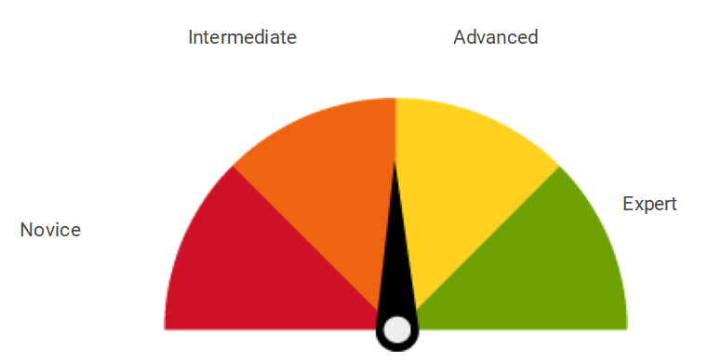 Total email etiquette Score: ____ <<Continue button>>  Split-screen layout
Instructions for Interactivity
- Play narration on screen open.
- Point score variable is added up from quiz question and displayed on screen open.
- Point score variable changes the state of the meter graphic to the following depending on score total (for this Demo only 1 point will either be added or deducted):
  - -1 = Novice
  - 1 = Intermediate
  - 2 = Advanced
  - 3 = Expert
- Slide Title, meter and texts appears on screen open.
- Sample emails fade in all at once.
- Custom Feedback Message displays by changing state of text box to the following depending on score total:
  - Expert = Congratulations! Your answers to email etiquette questions earned you an expert rating!
  - Advanced = Good work. Your answers to the email etiquette questions earned you an advanced rating!
  - Intermediate = Too bad! Your answers to the email etiquette questions earned you an intermediate rating! It would be a good idea to review the module.
  - Novice = Too bad! Your answers to the email etiquette questions earned you a novice rating! It would be a good idea to review the module.
- User selects “Continue” button to advance slide.

Screen 10
Audio Narration | Visuals
Proper email etiquette is important for fostering a professional and cordial working environment. Keep the following takeaways in mind next time your send or respond to an email. | Key Takeaways    On-screen Text:  Key Takeaways  (insert email icon)  Ideally, subject lines should inform the recipient about why you are emailing them. (insert email icon) 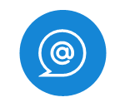 In the first line of an email while addressing the recipient, use a colon for formal emails and a comma for informal ones. (insert email icon)  Being neutral when corresponding via email is a safe bet and helps to avoid miscommunication.  Split top/bottom screen with 3 column layout
Instructions for Interactivity
- Play narration on screen open.
- Top image fades in on screen open.
- Texts and icons appear on-screen all at onces on screen open.
- User selects “next” button on player to advance slide.

Screen 11
Audio Narration | Visuals
You have completed the eLearning module: Email Etiquette for Corporate Professionals.  Select the “Exit Module” button to close the interactive. | Wrap-up  On-screen Text:  EMAIL ETIQUETTTE  For Corporate Professionals  Great Job! You have completed this module.  <<Exit Module>>  Split-screen layout
Instructions for Interactivity
- Play narration on screen open.
- Image on right fades in as slide loads.
- On-screen text fades in by paragraph.
- Exit Module button appears after narration cue.
- When user selects Exit Module button, the interactive window closes.

